ASSIGNMENT 1 BRIEF
Qualification | BTEC HND Diploma in Computing and Systems Development
Unit number and title | Unit 42: Programming in .NET
Assignment issued |  | Assignment due | Slot 39
Assessor name

Assignment title | Purpose of this assignment  This assignment considers the skills required to demonstrate knowledge and understanding in relation to Programming in .NET developments, in addition you will also be able to design effective solutions for given scenarios.  Scenario  You are an analyst/programmer working for a small IT start-up business, which, specializes in sports related software. The company uses C# in all of its developments and wishes to use .NET to take advantage of code re-use.  - Your first task is to produce a short written self-learning course for managers/senior developers that demonstrate the principles and features of .NET.
Aim of the assignment | This assignment satisfies the following learning outcomes and assessment criteria:  - LO 1: Understand the principles of programming using a .NET framework
Specific requirements  (see Appendix for assessment criteria and grade descriptors) | The Scenario:  ABC is a company selling laptops and computer accessories. The company is going to build a solution which helps the company to manage the business operations. Your software produced need to have following features:  - Managing Categories for administrators  - Managing Products for administrators  - Managing Orders for administrators  - Managing Customer’s queries for administrators [each query has 3 statuses: working, cancelled, done]  - Search product for a range of price for customers  Task 1 (LO 1: 1.1 and M1, M3, D1)  Produce a written, self-learning course for managers/senior developers that explain the principles and features of .NET programming.  Specifically you will discuss about  - Interoperability  - Backward compatibility  - Common runtime engine  - Language independence (multiple language support C#, J#, etc)  - Base class library  - Deployment  - Security  - Portability (because of Interoperability and Language Independence)  Hints:  Interoperability:  https://docs.microsoft.com/en-us/dotnet/csharp/programming-guide/interop/  Backward compatibility:  https://docs.microsoft.com/en-us/dotnet/framework/migration-guide/version-compatibility  Language independence  https://docs.microsoft.com/en-us/dotnet/standard/language-independence-and-language-independent-components  Base class library:  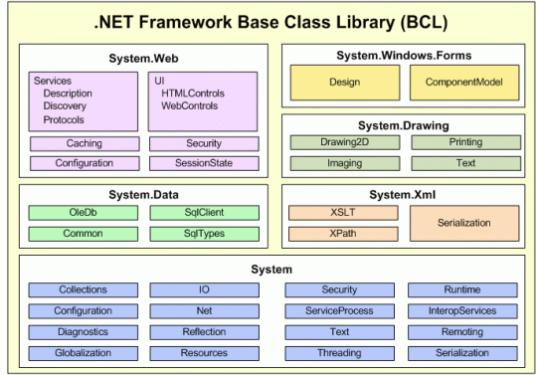  Deployment  https://docs.microsoft.com/en-us/dotnet/framework/deployment/deployment-guide-for-developers#clickonce-deployment  Security:  https://docs.microsoft.com/en-us/dotnet/standard/security/cryptography-model  Portability  http://www.mono-project.com/docs/about-mono/  Task 2 (LO 1: 1.2 and M1, M3, D1)  Critically compare different versions of .NET frameworks.  Specifically you will critically discuss about  - Current version  - Backward compatibility  - Design consideration (what are the changes, why do they change)  - Alternative implementation (e.g., Mono project, etc).  Hints:  Current version: State the latest version of .NET, release year, preinstall on windows version or separate installation  Backward capability: how it support previous version of .NET(see how latest features .NET support/ not support older versions or the features they removed from higher version)  Design considerations: Example of access database technology, how many way can you use to connect to the database such as ADO.NET, LINQ to ADO.NET  Alternative implementation: to use .NET beside windows operating system, what framework supports? (mono project example)  Task 3 (LO 1: 1.3 and M1, M3, D1)  Critically evaluate components of .NET Framework architecture  Specifically you will critically evaluate about  1. Common Language Runtime (CLR)  2. .NET Framework Class Library (FCL)  3. Common Type System (CTS)  4. Common Language Specification (CLS)  Hints:  CLR: https://docs.microsoft.com/en-us/dotnet/standard/clr  FCL: https://msdn.microsoft.com/en-us/library/gg145045(v=vs.110).aspx  CTS: https://docs.microsoft.com/en-us/dotnet/standard/base-types/common-type-system  CLS: https://msdn.microsoft.com/en-us/library/12a7a7h3(v=vs.100).aspx
Student guidelines | For the assignment assessments, you are required to:  1. Produce a report
Submission requirements | Students are expected to submit soft copy of assignment in PDF format

Grade Descriptor

PASS criteria

LO | Learning outcome  (LO) | AC | In this assessment you will have the  opportunity to present evidence that  shows you are able to: | Task  no.
LO1 | Understand the principles of programming using a .NET framework | 1.1 | discuss the principles, characteristics and features of programming using a .NET framework | 1
LO1 |  | 1.2 | critically compare different types of .NET framework architectures | 2
LO1 |  | 1.3 | critically evaluate the components that support the .NET framework | 3

In addition to the above PASS criteria, this assignment gives you the opportunity to submit evidence in order to achieve the following MERIT and DISTINCTION grades
Grade Descriptor | Indicative  characteristic/s | Contextualization
M1 Identify and  apply strategies to  find appropriate  solutions | Effective judgments have been made | All tasks, To achieve M1, you must provide effective judgments for all of the tasks
M3 Present and  communicate  appropriate  findings | A range of methods of presentation have been used and technical language has been accurately used | All tasks, to achieve M3, all tasks are presented clearly with good writing and format.
D1 Use critical  reflection to  evaluate own  work and justify  valid conclusions | Conclusions have  been arrived at  through synthesis  of ideas and have  been justified | All tasks, to achieve D1 you must provide conclusions for your discussions with concrete reasonings.

This brief has been verified as being fit for purpose
Internal Verifier 1 |  | Signature |  | Date
Internal Verifier 2 |  | Signature |  | Date

